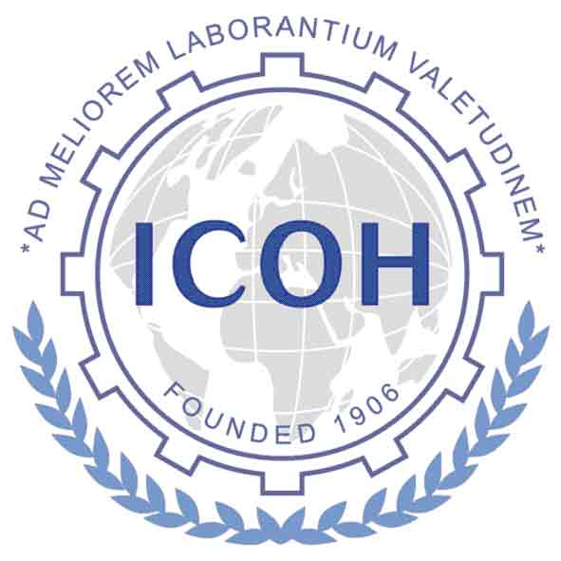
2022 -2024 Triennium Timetable of Deliverables
from Scientific Committees

Below is the tentative schedule of dates for the deliverables of the Scientific Committees (SCs). The dates relate to the Midterm Meeting of Officers, Board, and SC Chairs, which will be held during the second quarter of 2023, with date and location to be determined; and to the ICOH2024 Congress, which will be held in Marrakesh, Morocco from April 28 – May 3, 2024.

Forms (templates) are provided for each of the SC deliverables. These will be maintained in the SC Virtual Office on the ICOH website www.icohweb.org. You need to use your password or member number for access to the SC Virtual Office. Instructions for sending the requested deliverables are included in the forms.
NB - Please contact the ICOH Secretariat (icoh@inail.it) if you do not have access to the SC Virtual Office on the ICOH website.

Due dates for SC Deliverables:

By end of  June 2022 | Appointment Process  - Submission of the Transparency Declaration Form from SC Chair and Secretary  - Payment of membership fees for the triennium 2022 - 2024
July 31, 2022 | Report of SC Business Meeting associated with the ICOH 2022 Congress (held virtually pre- or post-congress)
By end of  August 2022 | SC Work Plan 2022 - 2024 to include:  - Planned work of the SC  - List of Members of the SC
September -November 2022 | ICOH2024 SC recommendations:  (Dates will depend on the Moroccan Organizers’ schedule)  - Scientific topics and speakers (for plenary and semi-plenary presentations)  - SC Special Session reservation  - Reviewers for Abstracts of Free Paper Topics
December 2022 – February 2023 | ICOH2024 SC Business Meeting Reservation
March 1, 2023 | SC Triennium Midterm Report – deadline for submission to VP
January 1, 2024 | SC Triennium Final Report – deadline for submission to VP
As needed | Notes from SC Business Meetings
As needed | SC Sponsorship Funding Request (mainly for ICOH members from LMICs to attend SC events in virtual or in-presence formats)

